# Software Development, Maintenance, and SQA Environment

Software development and maintenance is performed under a series of legal, managerial, social, and technological requirements. These requirements may be defined as the “software development, maintenance, and SQA environment.” Whoever participates in software development and quality assurance activities is required to cope and deal with these environment requirements.

# Main Characteristics of Software Development, Maintenance, and SQ

1. **Contractual Conditions of Software Development, Maintenance, and SQA activities:** The commitments and conditions between the software developer–maintainer and the customer are defined in the contract. The contract affects the activities of software development that include, in addition to development, the delivery, installation, and running-in activities, and the maintenance activities include software operation and the three types of maintenance activities.
2. **Subjection to Customer-Supplier Relationship:** All software development and SQA activities throughout the process are overseen by the customer, and therefore it is of great importance that the project team continuously maintains a cooperative working relationship with the customer. It is the need to maintain customer- supplier relationships required for consultations with the customer, customer approvals, and more.
3. **The Need for Teamwork:** Three factors usually motivate the establishment of a project team, rather than assigning the whole project to just one professional:
   * Schedule requirements
   * The need for a range of professional specializations in order to carry out the project
   * The objective to benefit from professional mutual support
4. **The need for cooperation and coordination with other internal development teams:** The carrying out of projects, especially larger projects, by more than one team is a very common event in the software industry, and cooperation and coordination may be required with the following:
   * Other software development teams in the same organization
   * Hardware development teams in the same organization
5. **The need for cooperation and coordination with external participants in the software development project:** Namely, software and hardware suppliers, subcontractors and outsourcing development teams, partner teams, and, in many cases, also customer development teams participating in the project.
6. **The required product interfaces with other software systems:** Today, most software systems include interfaces with other software packages. These interfaces allow data in electronic form to flow between the software systems.
   * Input interfaces
   * Output interfaces
   * Input and output interfaces to a software system
7. **The need to continue carrying out a software project despite team member changes:** It is the team leader’s responsibility to replace the departing team member with either another company employee or a newly recruited employee. It should be noted that the software project includes the development phases as well and the delivery, installation, and running-in phases.
8. **The need to maintain software systems for extended periods:** Customers who develop or purchase a software system expect to continue utilizing it for a long time, usually for 5–10 years. During the service period, the need for maintenance will eventually arise. In most cases, the developer is required to supply these services directly.

# Top Management and Project Management for Software Quality

**Top Management’s Quality Assurance Activities:** Top management is expected to:

1. Communicate the importance of software products and services, meeting customer and regulatory requirements to employees at all levels.
2. Establish a software quality policy and ensure that quality objectives related to the company’s software products and software maintenance services are established and accomplished consistently.
3. Ensure that quality objectives are established for the organization’s SQA system and that they are accomplished.
4. Ensure the availability of the resources required for performing software quality assurance activities.
5. Conduct periodical management reviews.

The following are the three (3) main tools available to top management for the fulfillment of its responsibilities:

* + Establish and update the organization’s software quality policy.
  + Assign one of the executives to be responsible for software quality issues.
  + Conduct regular management reviews of performance.

# Project Management Responsibilities for Quality

Most project management responsibilities are defined in procedures and work instructions; the project manager is the person in charge of making sure that all the team members comply with the said procedures and instructions. His tasks include professional hands-on and managerial tasks.

# Professional Hands-on Tasks:

1. Preparation of project and quality plans and their updates
2. Participation in joint customer-supplier committees
3. Close professional follow-up regarding the implemented solutions and method, and professional support when needed
4. Close follow-up of project team staffing including attending to recruitment, training, and instruction

**Managerial Tasks:** Project managers address the follow-up issues:

1. Progress control of project schedule, budget, and project risk handling
2. Performance of review activities and the consequent corrections, including participating in reviews
3. Software development and maintenance unit performance with respect to development, integration, and system test activities as well as corrections and regression tests
4. Performance of acceptance tests
5. Software installation in customer sites and the running-in of the software system by the customer
6. SQA training and instruction of project team members
7. Schedules and resources allocated to project activities (many interventions to correct deviations)
8. Customer requests and satisfaction.
9. Evolving project development risks, application of solutions, and control of results

The structure of an SQA unit varies according to the type, and of course, the size of the organization. Below is the proposed model for an SQA Unit’s organizational structure.

**.**

**The SQA Unit**

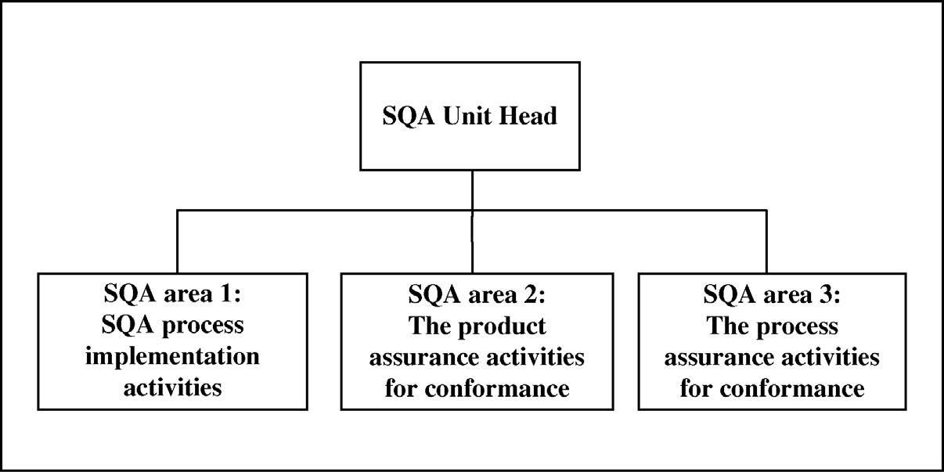

# SQA Area 1: SQA Process Implementation Activities

The SQA tasks may be classified into five groups:

* + **Establishing SQA processes and their coordination with the software development processes:** Supporting the establishment, updating, and implementation of the organizational quality policy.
  + **SQA plan and project plan:** Preparing a comprehensive SQA plan (SQAP) that includes the SQA activities and responsibility for their performance, including the evaluation of software product risks.
  + **Pre-project process–contract review:** Supporting the organization to carry out contract reviews.
  + **Cost of software quality:** Evaluating the costs of software quality according to the findings of the SQAP activities conducted.
  + **SQA records and documentation control:** Documenting the findings of SQAP activities to provide the required performance evidence.

# SQA Area 2: The Product Assurance Activities for Conformance

SQA tasks performed by product assurance activities for conformance of the SQA area may be classified into three groups:

* + **Evaluation of Products for conformance** - identifying the established requirements relating to the software products and their documentation, and evaluating the product and its documentation conformance with the requirements
  + **Assuring quality conformance of software operation services** - performing regular measurements of the level of customer support services and their conformance to the service plans
  + **Software product quality metrics** - analyzing product measurement procedures to determine whether they satisfy measurements required by contract, and project’s processes and plans

# SQA Area 3: The Process Assurance Activities for Conformance

The SQA tasks performed by the process assurance activities for conformance SQA area may be classified into six (6) groups:

* + **Evaluation of processes for conformance -** evaluating project plans and the selected software lifecycle processes for appropriateness to meet the contract requirements
  + **Evaluation of the environment for conformance** - evaluating the software engineering environment for conformance to the relevant contract requirements.

# Improvement processes – corrective and preventive actions

- supporting the corrective and preventive actions in evaluation process records and developing improvement proposals.

* + **Software process assurance activities for subcontractors** - identifying process requirements from subcontractors as defined in the contracts with subcontractors.
  + **Software process quality metrics** - allocating standards and procedures used by the project or organization.
  + **Staff skills and knowledge – training and certification** - identifying gaps between the required skills and professional knowledge for carrying out a project, and the current skills and knowledge of the project staff in place.

# The Associated Players in the SQA System

A major part of the SQA system is the SQA function/team. Additional players in the SQA system include interested practitioners found among the software development and maintenance staff. These people with interest in SQA contribute to the SQA system in the following formats:

* + SQA Trustees
  + SQA Committee Members
  + SQA Forum Members

# SQA Trustees and their Tasks

**SQA Trustees:** Staff members who, being strongly interested in software quality, volunteer part of their time to promoting quality. They are frequently instructed by the SQA unit on new and updated subjects of interest. Trustees are expected to provide the internal support necessary to successfully implement SQA components. Trustees’ tasks vary substantially among organizations. Tasks may be unit related and/or organization related, and include some or all of the following activities:

# Unit Related Tasks:

* + - Support their colleagues’ attempts to solve difficulties arising in the implementation of software quality procedures and work instructions.
    - Help their unit manager to perform his or her SQA tasks.
    - Promote compliance and monitor implementation of SQA procedures and work instructions by colleagues.
    - Report substantial and systematic non-compliance events to the SQA unit.
    - Report severe software quality failures to the SQA unit.

# Organization Related Tasks:

* + - Initiate changes and updates of organization-wide SQA procedures and work instructions.
    - Initiate organization-wide improvements of development and maintenance processes and applications to the CAB for solutions to recurrent failures observed.
    - Identify organization-wide SQA training needs and propose an appropriate training or instruction program to be carried out by the SQA unit.

# SQA Committees and their Tasks

SQA committees can be either permanent or ad hoc. The subjects dealt with the authority granted, as well as the division of tasks between permanent and ad hoc committees, vary considerably among organizations.

* + **Permanent Committees** - commonly deal with SCC (Software Change Control), CA (Corrective Actions), procedures, methods, development tools, and quality metrics. They are integral parts of the SQA organizational framework; their tasks and scope of operation are usually defined in the organization’s SQA procedures.
  + **Ad hoc Committees** - commonly deal with specific cases, such as updates of a specific procedure, analysis and solution of a software failure, elaboration of software metrics for a targeted process or product, and updates of data collection methods for a specific issue. Ad hoc committees are established on a short- term, per-problem basis, with members nominated by the executive responsible for software quality issues, the head of the SQA Unit, and the head of SQA ad hoc committee.

**References:**

Galin, D. (2018). Software Quality Assurance – Concepts and Practice: IEEE Computer Society, Inc.

Laporte, C. and April, A. (2018). Software Quality Assurance: IEEE Computer Society, Inc.

# SQA Forums – Tasks and Methods of Operation

SQA forums are informal components of the SQA organizational framework; they are established by volunteers and display some features of a community. The forums operate rather freely, as are not subject to any standard requirements or procedures. An organization generally benefits from the activities of its SQA forums, which can function independently or in some kind of cooperative relationship. Members of an SQA forum usually define its scope and mode of operation, which can be limited or broad in scope. SQA forums typically focus on:

* + SQA procedures’ improvement and implementation
  + Quality metrics
  + Corrective actions – analysis of failure and success cases
  + Quality system issues – development and implementation of new tools
  + Quality line management problems – daily operational software quality problems brought before it by quality managers from every level.